**Major Project Synopsis**

***on***

**MAKEITEASY**

***In partial fulfillment of requirements for the degree***

***of***

**BACHELOR OF ENGINEERING**

**IN**

**INFORMATION TECHNOLOGY**

***Submitted by:***

AKSHAT GAWSHINDE [18100BTCSICS02996]

SAKSHAM JHA [18100BTCSICS03033]

SAKSHI MODI [18100BTCSICS03034]

UJJWAL THAKRE [18100BTCSICS03043]

***Under the guidance of***

PROF. ANAND SINGH GADWAL

PROF. GAURAV VINCHURKAR



**DEPARTMENT OF INFORMATION TECHNOLOGY**

**SHRI VAISHNAV INSTITUTE OF INFORMATION TECHNOLOGY**

**SHRI VAISHNAV VIDYAPEETH VISHWAVIDYALAYA, INDORE**

**JULY-DEC 2021**

**SHRI VAISHNAV INSTITUTE OF INFORMATION TECHNOLOGY**

**DEPARTMENT OF INFORMATION TECHNOLOGY**

**GUIDELINES FOR MINOR PROJECT SYNOPSIS**

**DECLARATION**

We here declare that work which is being presented in the project entitled “**MAKEITEASY**” in partial fulfillment of degree of **Bachelor of Technology in Information Technology** is an authentic record of our work carried out under the supervision and guidance of **Mr.** **ANAND SINGH GADWAL** Asst. Professor of Information Technology. The matter embodied in this projecthas not been submitted for the award of any other degree.

**SHRI VAISHNAV VIDYAPEETH VISHWAVIDYALAYA, INDORE**

**SHRI VAISHNAV INSTITUTE OF INFORMATION TECHNOLOGY**

**DEPARTMENT OF INFORMATION TECHNOLOGY**

**PROJECT APPROVAL SHEEET**

Following team has done the appropriate work related to the “**MAKEITEASY**” in partial fulfillment for the award of **Bachelor of Technology in Information** **Technology** of “SHRI VAISHNAV INSTITUTE OF INFORMATION TECHNOLOGY” andis being submitted to SHRI VAISHNAV VIDYAPEETH VISHWAVIDYALAYA, INDORE.

**Team:**

1. **Akshat Gawshinde**
2. **Saksham Jha**
3. **Sakshi Modi**
4. **Ujjwal Thakre**

**Mr. Anand Singh Gadwal** **Mr. Gaurav Vinchurkar**

**SHRI VAISHNAV VIDYAPEETH VISHWAVIDYALAYA, INDORE**

**SHRI VAISHNAV INSTITUTE OF INFORMATION TECHNOLOGY**

**DEPARTMENT OF INFORMATION TECHNOLOGY**

**CERTIFICATE**

This is to certify that **Mr. Akshat Gawshinde**, **Ms. Saksham Jha, Ms. Sakshi Modi** and **Mr. Ujjwal Thakre** working in a team have satisfactorily completed the project entitled “**MAKEITEASY**” under the guidance of Mr. Jayesh Surana in the partial fulfillment of the degree of **Bachelor of Technology in Information Technology** awarded by SHRI VAISHNAV INSTITUTE OF INFORMATION TECHNOLOGY affiliated to SHRI VAISHNAV VIDYAPEETH VISHWAVIDYALAYA, INDORE during the academic year **Jul** **2021-Dec 2021**.

|  |  |
| --- | --- |
| (Mr. Anand Gadwal) |  |
| (Mr. Gaurav Vinchurkar) | Prof. Manish Kumar |
| **Project Guide** | **Project Coordinator** |

Dr. Jigyasu Dubey

**Head, Department of Information Technology**

**ACKNOWLEDGEMENT**

We are grateful to a number of persons for their advice and support during the time of complete our project work. First and foremost our thanks goes to **Dr. Jigyasu Dubey** Head of the Department of Information Technology and **Mr. Anand Singh Gadwal** and **Mr. Gaurav Vinchurkar** the mentor of our project for providing us valuable support and necessary help whenever required and also helping us explore new technologies by the help of their technical expertise. His direction, supervision and constructive criticism were indeed the source of inspiration for us.

We would also like to express our sincere gratitude towards our Director **Dr. Anand Rajavat**  for providing us valuable support.

We are really indebted to **Prof. Manish Kumar,** project coordinator for helping us in each aspect of our academics activities. We also owe our sincere thanks to all the **faculty members** of Information Technology Department who have always been helpful.

We forward our sincere thanks to all **teaching and non-teaching staff** of Information Technology department, SVVV Indore for providing necessary information and there kind co-operation.

We would like to thanks our parents and family members, our classmates and our friends for their motivation and there valuable suggestion during the project. Last, but not the least, we thank all those people, who have helped us directly or indirectly in accomplishing this work. It has been a privilege to study at SHRI VAISHNAV VIDYAPEETH VISHWAVIDYALAYA, INDORE.

**ABSTRACT**

**Online Examination System** refers to a software solution, which allows any industry or institute to arrange, conduct and manage examinations via an online environment. MAKEITEASY is a website designed primarily for use in the institutes. This is a web-based examination system where examinations are given online. either through the internet or intranet using computer system. The main goal of this online examination system is to effectively evaluate the student thoroughly through a totally automated system that not only reduce the required time but also obtain fast and accurate results.

System Development life cycle(SDLC) which is a conceptual model used in project management that describes the stages involved in an information system development project.

Database includes Admin can prepare the questions from different subjects and restaurant students will attempt the test and submit the answer sheet and then can get the results of their accuracy, and also they can analyze in which subject they have to perform more better. This makes easy for students to recognize their weak part and then they have to work more only on the weakest part.

**TABLE OF CONTENT**

Declaration

Project Approval Sheet

Certificate

Acknowledgment

Abstract

List of Figures

CHAPTER 1 – **INTRODUCTION**

1. Introduction
2. Problem Statement
3. Need for the proper System
4. Objective
5. Modules of the system
6. Scope

CHAPTER 2 - **LITERATURE SURVEY**

1. Proposed System
2. Feasibility Study
   * + 1. 2.2.1 Technical Feasibility
     1. Economical Feasibility
     2. Operational Feasibility

CHAPTER 3 – **REQUIREMENTS ANALYSIS**

1. Method used for Requirement analysis
2. Functional Requirements
3. Non-Functional Requirements
4. System Specification
   1. Hardware specification
   2. Software Specification

CHAPTER 4 – **DESIGN**

1. Use Case Model
2. Database Design (ER-Diagram)
3. Data flow Diagram(Level 0,1)

|  |  |
| --- | --- |
| CHAPTER 5 – **SYSTEM MODELING**  5.1 Class Diagram  5.2 Sequence Diagram  5.3 State Diagram  5.4 Deployment Diagram  5.5 Test Plans And Implementation Images | |
| CHAPTER 6 – **CONCLUSION & FUTURE WORK** | |
| 6.1 | Limitation of Project |
| 6.2 | Future Enhancement |
| CHAPTER 7 - **BIBLIOGRAPHY & REFERENCES** | |

1. Reference Books
2. Other Documentations & Resources

**CHAPTER 1-INTRODUCTION**

1. **Introduction**

Online Quiz System refers to service that conduct online test series. It will use for students’ progress evaluation using modern computer technology. It replaced the paperwork and overcome the outcomes of traditional way of examinations using paper or pen.It is web based platform can be used at any remote location. Online Quiz System is fully developed automated system is to efficiently evaluate the candidate progress that not only save the time and also gives fast result. It is cost effective and time effective. Candidate can give their tests in a specific duration and in specific number of questions. The questions can be appear in both mode MCQ (Multiple Choice Questions) and answer in paragraph based on the subject category he is choosing.

1. **Problem Statement**

The first problem is lecturers need spend more time on grading. This is because lecturer need to check student paper one by one. The second problem is difficult for students to answer quiz from any location. Quiz give an impact in coursework. Sometime some students have their own reason cannot take quiz on time. In reality, lecturers and students were really important and they play a big role in setup the quiz. Besides, lecturers can test their students’ knowledge by grading. Here, the reasons to develop a web-based quiz system.

1. **Need For The Project**

Online examination was developed to examine the student’s technical knowledge. Due to increasing in industry online examination came into existence for example like Aptitude test or placement purpose. In online examination students are available with one question and more than two answers, students are independent to choose their answer. In online examination system makes the result available at minimum time. The results are more accurate.

1. **Objective**

The main aim of Online Quiz System is to reduce the hectic job of assessing the answers given by candidates manually. It will use for students progress evaluation using modern computer technology. It replaced the paperwork and overcome the outcomes of traditional way of examinations using paper or pen . It is web based platform can be used at any remote location. Online Quiz System is fully developed automated system is to efficiently evaluate the candidate progress that not only save the time and also gives fast result. It is cost effective and time effective. Candidate can give their tests in a specific duration and in specific number of questions. The questions can be appear in both mode MCQ (Multiple Choice Questions) and answer in paragraph based on the subject category he is choosing.

1. **Modules Of System**

The various module used in this project is described below:

* **Student module**

In this module, we collect the student’s details at the time of signing up

* Roll No.
* Name
* Father Name
* Mother Name
* Gender
* Contact
* Email
* Education Details
* Address
* **Question module**

In this module, admin adds the new questions

* Quesid
* Name
* Option1
* Option2
* Option3
* Option4
* Answer

1. **Scope**

The main objective of this project is to conduct online test which will help users to become self-paced learners and to make them aware of examination pattern of many competitive exams.

Some of the aim of the project includes: -

* Help students to go beyond their normal curriculum and learn about various other aspects which are apart from academic education.
* To provide quiz where, there is virtually no scope of errors and the results are much faster. And the system is more transparent.
* To provide an environment where students not only can learn but also analyze their performance simultaneously.

To train the students to work within time limit with constraints.

**CHAPTER 2-LITERATURE SURVEY**

**Sources of Information**

We have been to many websites to understand their process of maintaining database and the level of efficiency they have in their system and drawbacks of their existing systems. After visiting many such sites, we thought of developing an application which will overcome the drawbacks of the existing systems.

* **Primary sources**
* Web sites
* Suggestion from friends
* **Secondary sources**
* Reference Materials

1. **Proposed System**

This system is expected to be implemented in web-based. The system will focus on quiz in different categories and will be totally free. In addition, this system more secure because of no chances of data leakage. Additionally, this system also less time consuming and is more efficient. Student can analyse their growth and accuracy. This is because analysis will be very easy in proposed system as it is automated. Result will be very precise and accurate and will be declared in very short span of time because calculation and evaluations are done by the simulator itself.

**The proposed system has the following requirements:**

* System needs to store information about new entry of students
* System need to maintain quantity record
* System need to update and delete the record
* System also needs search area

1. **Feasibility Study**

A feasibility study is a high-level capsule version of the entire System analysis and Design Process. The study begins by classifying the problem definition. Feasibility is to determine if it’s worth doing. Once an acceptance problem definition has been generated, the analyst develops a logical model of the system. A search for alternatives is analysed carefully. There are 3 parts in feasibility study.

1. Operational Feasibility
2. Technical Feasibility
3. Economic Feasibility
   * 1. **Operational Feasibility**

Operational feasibility is the measure of how well a proposed system solves the problems, and takes advantage of the opportunities identified during scope definition and how it satisfies the requirements identified in the requirements analysis phase of system development.The operational feasibility assessment focuses on the degree to which the proposed development projects fits in with the existing business environment and objectives with regard to development schedule, delivery date, corporate culture and existing business processes.To ensure success, desired operational outcomes must be imparted during design and development. These include such design-dependent parameters as reliability, maintainability, supportability, usability, producibility, disposability, sustainability, affordability and others. These parameters are required to be considered at the early stages of design if desired operational behaviours are to be realised. A system design and development requires appropriate and timely application of engineering and management efforts to meet the previously mentioned parameters.

* + 1. **Technical Feasibility**

This involves questions such as whether the technology needed for the system exists, how difficult it will be to build, and whether the firm has enough experience using that technology. The assessment is based on outline design of system requirements in terms of input, processes, output, fields, programs and procedures. This can be qualified in terms of volume of data, trends, frequency of updating inorder to give an introduction to the technical system. The application is the fact that it has been developed on windows XP platform and a high configuration of 1GB RAM on Intel Pentium Dual core processor. This is technically feasible .The technical feasibility assessment is focused on gaining an understanding of the present technical resources of the organization and their applicability to the expected needs of the proposed system. It is an evaluation of the hardware and software and how it meets the need of the proposed system.

* + 1. **Economical Feasibility**

Establishing the cost-effectiveness of the proposed system i.e. if the benefits do not outweigh the costs then it is not worth going ahead. In the fast paced world today there is a great need of online social networking facilities. Thus the benefits of this project in the current scenario make it economically feasible. The purpose of the economic feasibility assessment is to determine the positive economic benefits to the organization that the proposed system will provide. It includes quantification and identification of all the benefits expected. This assessment typically involves a cost/benefits analysis.

**CHAPTER 3-REQUIREMENT ANALYSIS**

* 1. **Method used for Requirement Analysis**

This is very first responsibility of a Analyst to gather requirements from the client. It can be done by communicating with stakeholders directly or by doing some research, experiments. There are various ways to gather the information based on client’s requirement. In our project we have used:

* **Brainstorming**

This technique is used to generate new ideas and find a solution for a specific issue. We have discussed with our friends and teammates about the additional features we should use which makes are website different from others. At last, we had multiple ideas and information which has given us a repository of knowledge that we have chosen from different ideas. Following are the points that we have concluded to pay attention on and give priority to:

* What is the expectation of a system?
* What are the risk factors that affect the proposed system development and what to do to avoid that?
* What are the business and organization rules required to follow?
* What are the options available to resolve the current issues?
* What should we do so that this particular issue does not happen in the future?

This session was conducted on online platform and we also had a table discussion with our friends. Every participant have been given an equal amount of time to express their ideas.

**Brainstorming can be described in the following phases:**

[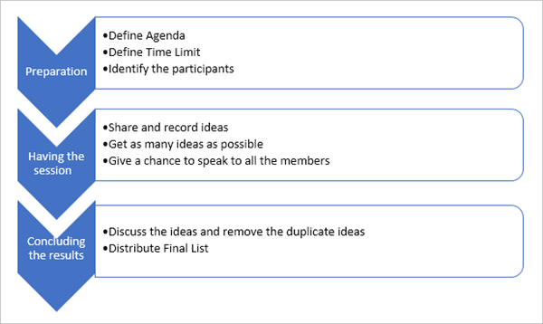](https://www.softwaretestinghelp.com/wp-content/qa/uploads/2018/09/Brainstorming.png)

**Benefits**:

* Creative thinking is the result of the brainstorming session.
* Plenty of ideas in a short time.
* Promotes equal participation.

**Drawbacks:**

* Participants can be involved in debating ideas.
* There can be multiple duplicate ideas.
  1. **Functional requirement**

In this section we describe the functional capabilities of the system. For each functional requirement, the required inputs, desired outputs and processing requirements are specified.

* **Validation to be performed**
* The students enters the user id and password in the appropriate text box.
* Source of input : Login Box
* Input : UserID, Password
* Output : Home page will open with additional options.
* **New User Registration**
* This page provides registration for the new customer. User have to fill the appropriate form with valid entry.
* Source of input : New User Registration
* Input : Name, ID, Branch, Category
* Output : After entering the appropriate details of user it will be validated and added to database for future use. From onwards user can login and give test.
* **Conduct Test**
* Source of input :- Take Test
* Input : Category, Question, Correct Choice
* Output : After successful submission the the marks will be evaluated and the result will be displayed with all its details.
* **User details and performance**
* Source of input : Student details and performance
* Output : Score card and graphical analysis of the progress
  1. **Non-functional Requirement**
* **User interfaces**

All activities of MakeItEasy have screen-based interaction. It incorporates with effective GUI concepts and focuses on user-friendly systems. It has good, appealing, attractive, and aesthetic web pages with optimum hyperlink to select the required process. Home page of MakeItEasy provides all the basic information that the user require for successful processing.

* **Software Interfaces**

Interfacing with several modules in order to perform various it requires Database Connectivity (MySQL), Server interfacing.

Apart from this, Non-functional requirements are those requirements that constitute the overall attributed of the system such as portability, performance, security, etc.

* **Portability**

System running on one platform can easily be converted to run on another platform.

* **Reliability**

The ability of the system to behave consistently in a user-acceptable manner when operating within the environment for which the system was intended.

* **Availability**

The system should be available at all times, meaning the user can access it using a web browser, only restricted by the down time of the server on which the system runs.

* **Maintainability**

A commercial database is used for maintaining the database and the application server takes care of the site.

* **Security**

Secure access of confidential data (customer information).

* **User friendly**

System should be easily used by customer.

* **Performance**

Performance should be fast.

* **Efficient**

System should be efficient that it won’t get hang if heavy traffic of orders is placed.

* **Safety**

Data in the database of system should not loss or damage.

* **Privacy**

Personal data of the system should not disclose to anyone.

* 1. **System Specification**
     1. **Hardware specification**
     + 60 MB or more free hard-drive space
     + 128 MB RAM
     + Intel i3 or above
     1. **Software specification**

Operating System: Windows (Vista/7 or above)

Language: JAVA

Web Browser: Google Chrome, Internet Explorer or Mozilla Firefox

IDE: Eclipse

**CHAPTER 4-DESIGN**

1. **Use Case Model**

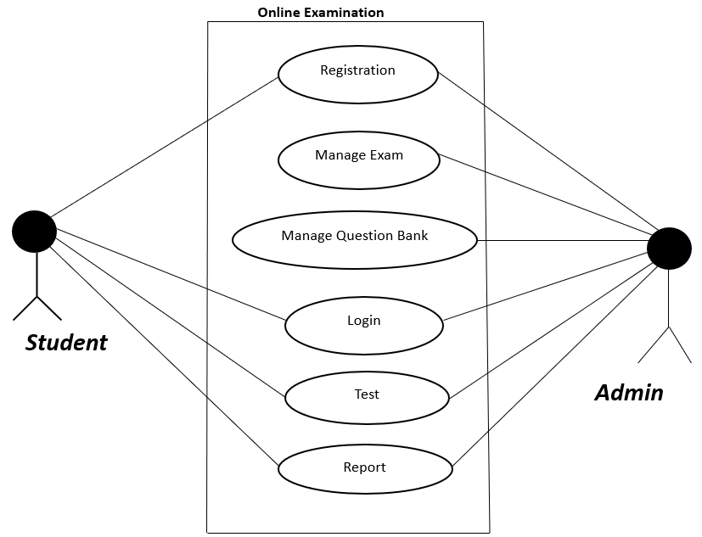

* 1. **ER Diagram**

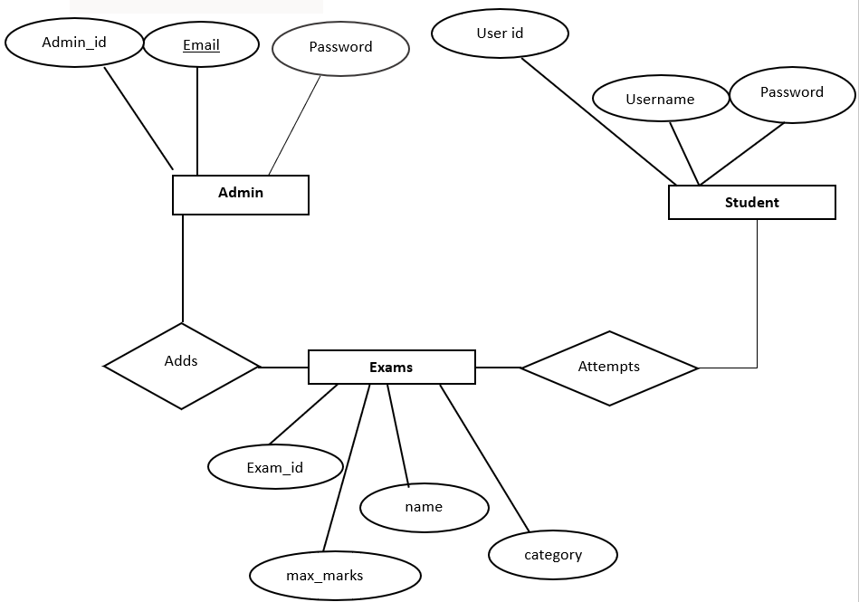

* 1. **Dataflow Diagram(level 0)**

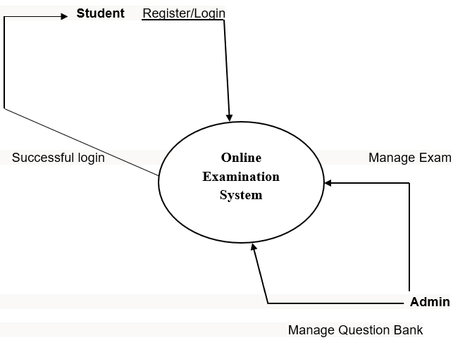

**Dataflow Diagram (level 1)**

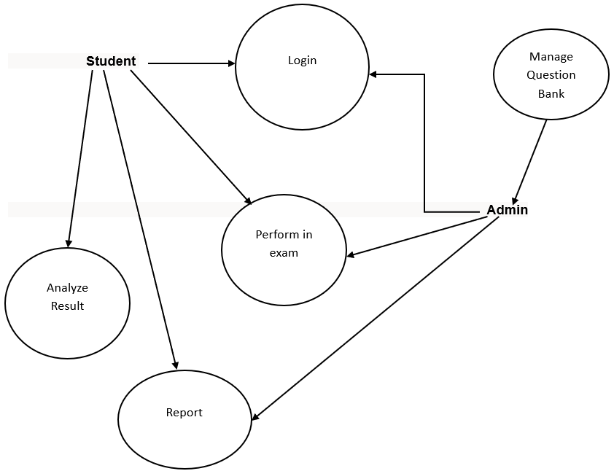

**CHAPTER 5-SYSTEM MODELING**

**5.1 Class Diagram**

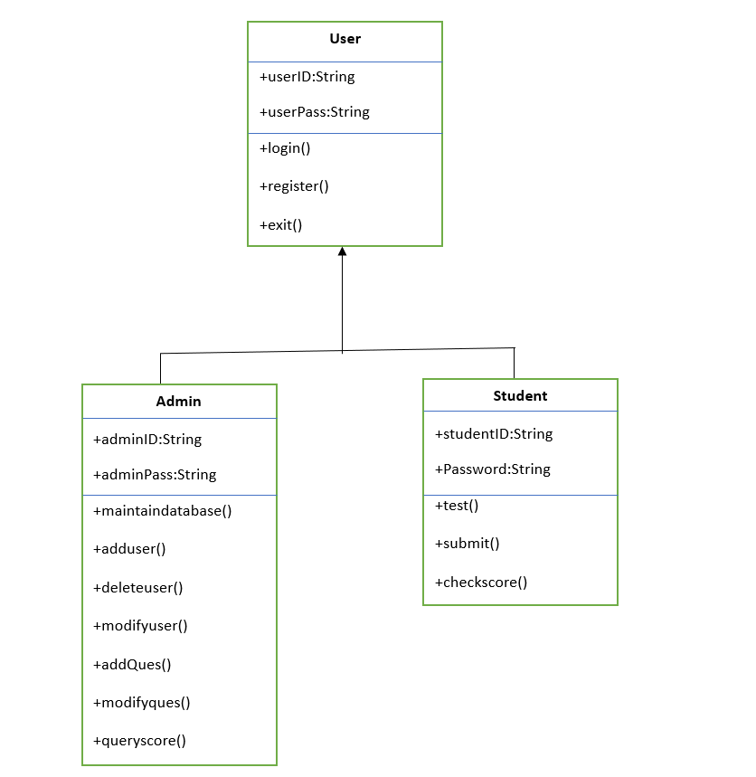

**5.2 Sequence Diagram**

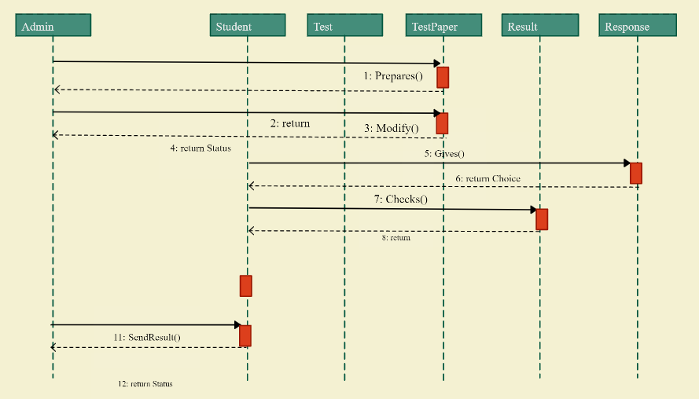

**5.3 State Diagram**

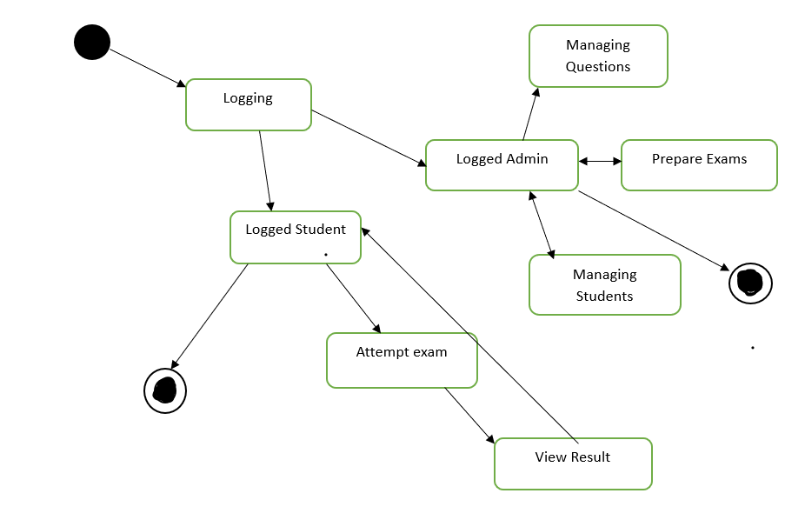

**5.4 Deployment Diagram**

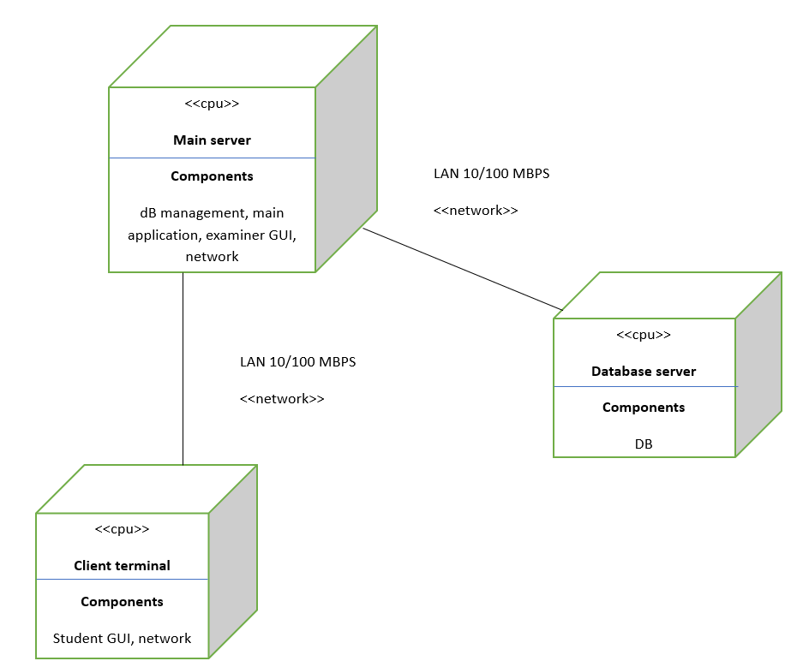

**Collaboration Diagram**

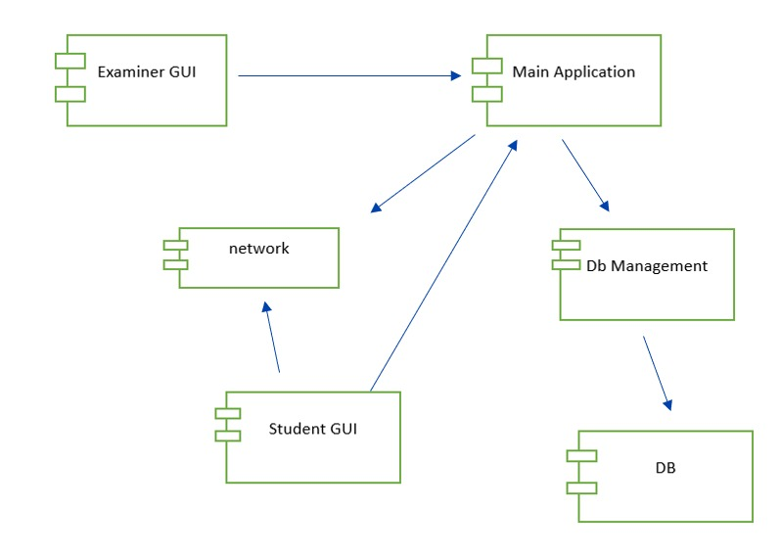

**5.5** **Test Plans and Implementation Images**

* **Test Plan**
* A Test Plan refers to a detailed document that catalogs the test strategy, objectives, schedule, estimations, deadlines, and the resources required for completing that particular project. Think of it as a blueprint for running the tests needed to ensure the software is working properly – controlled by test managers.
* A well-crafted test plan is a dynamic document that changes according to progressions in the project and stays current at all times. It is the point of reference, based on which testing activities are executed and coordinated among a QA team.

**Components of a Test Plan**

* **Scope:** Details the objectives of the particular project. Also, it details user scenarios to be used in tests. If necessary, the scope can specify what scenarios or issues the project will not cover.
* **Schedule:** Details start dates and deadlines for testers to deliver results.
* **Resource Allocation:** Details which tester will work on which test.
* **Environment:** Details the nature, configuration, and availability of the test environment.
* **Tools:** Details what tools are to be used for testing, bug reporting, and other relevant activities.
* **Risk Management**: Details what risks may occur during software testing, and what risks the software itself may suffer if released without sufficient testing.
* **Exit Parameters**: Details when testing activities must stop. This part describes the results that are expected from the QA operations, giving testers a benchmark to compare actual results.
* **Implementation Images**

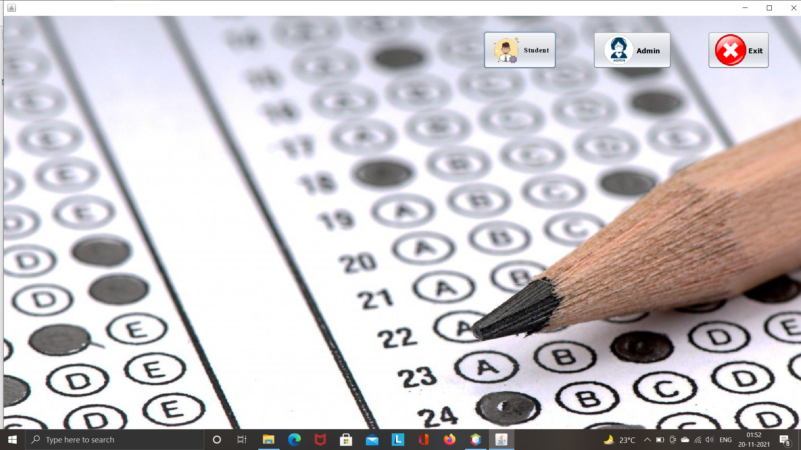

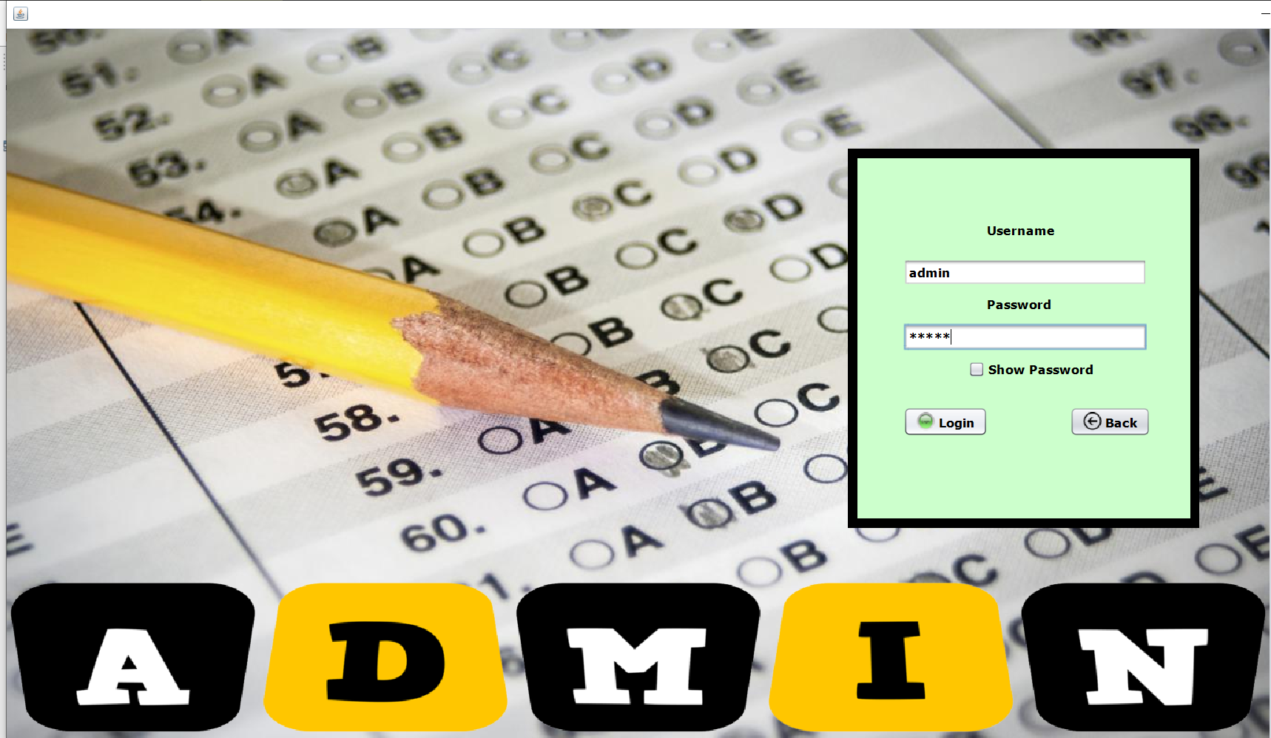

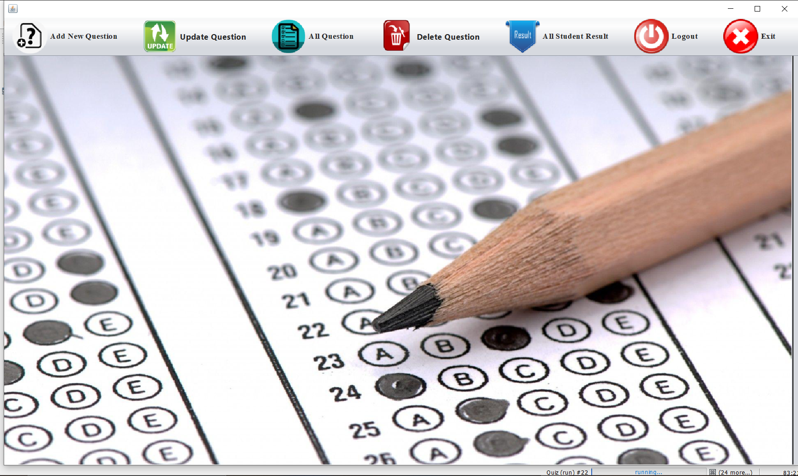

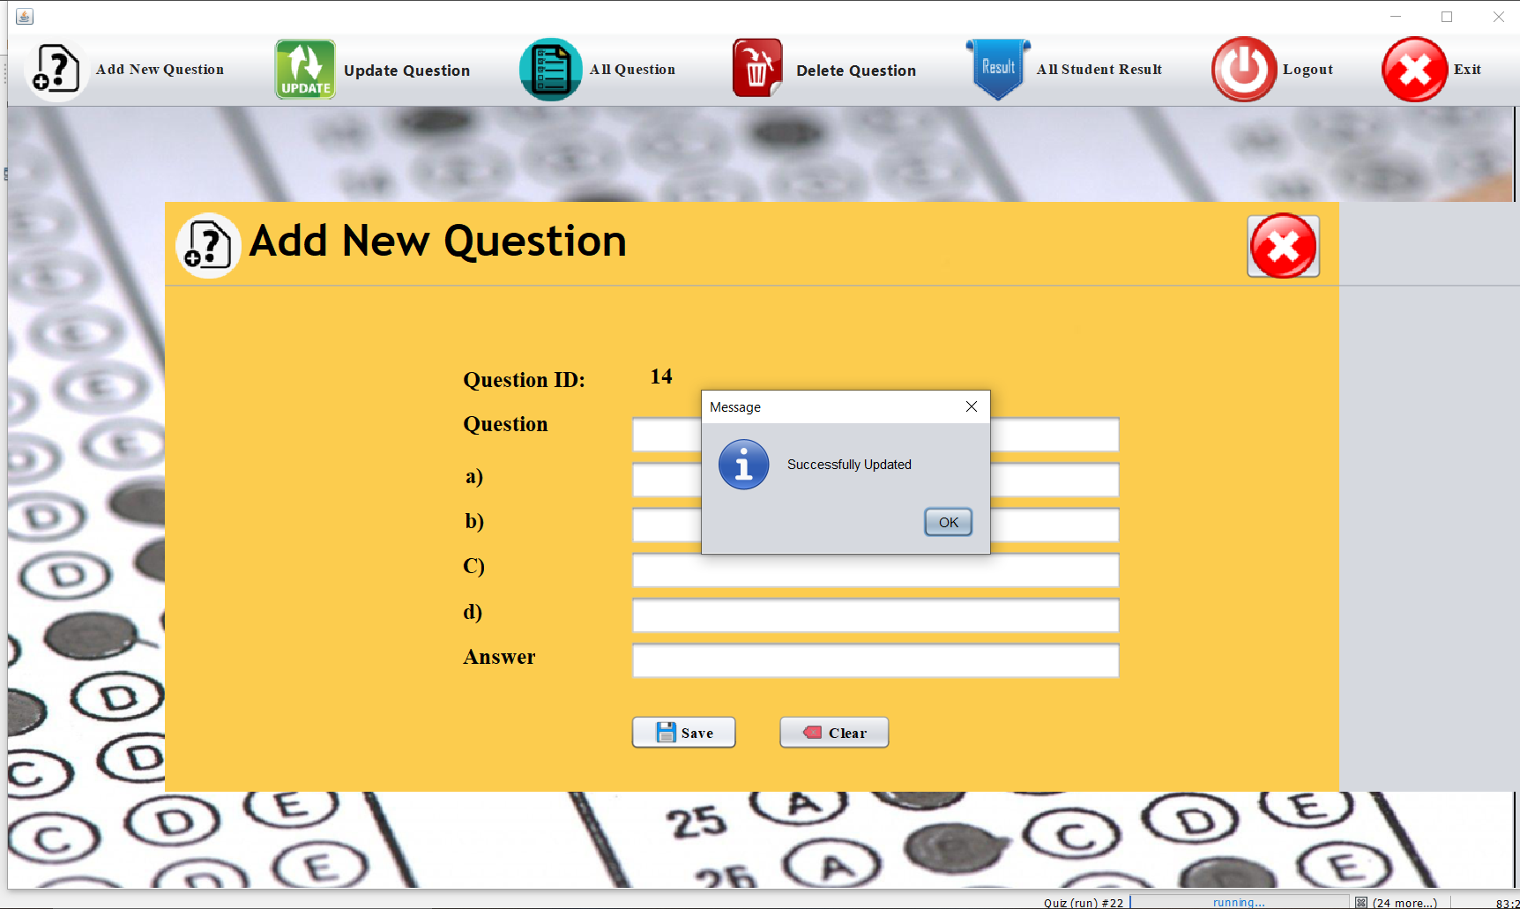

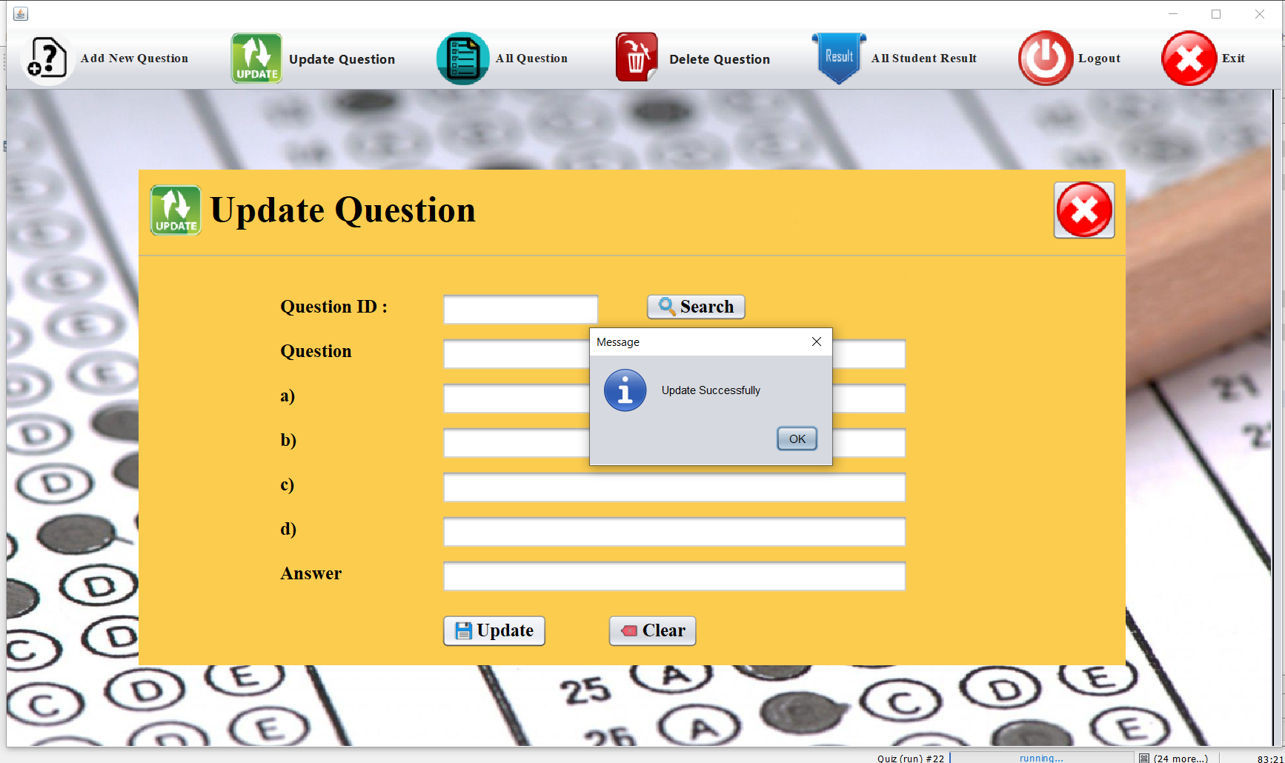

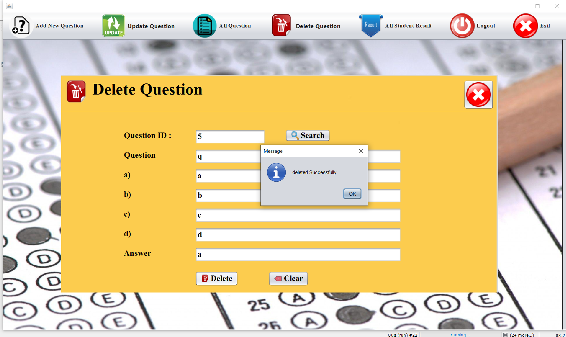

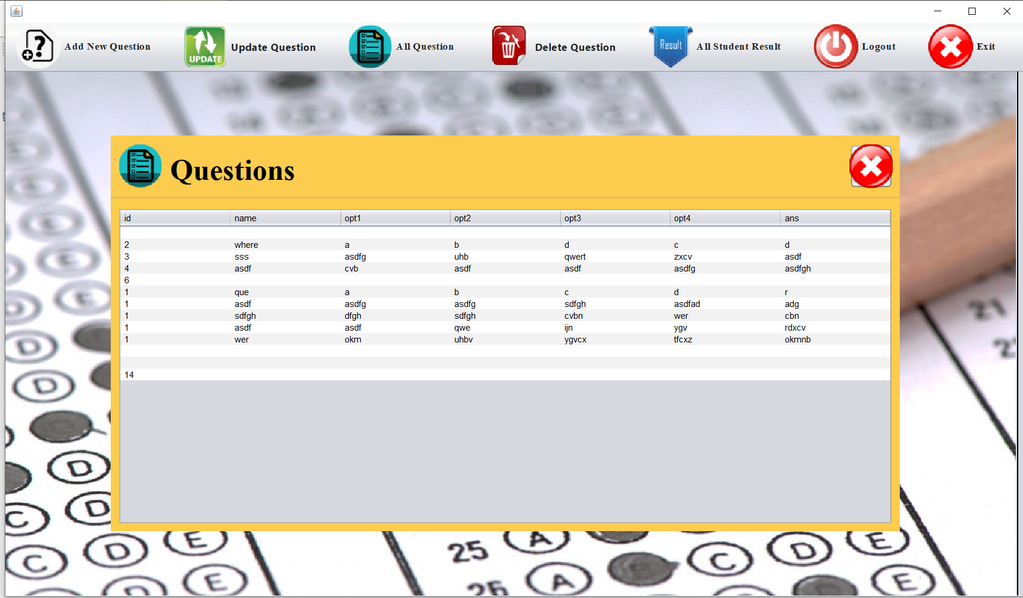

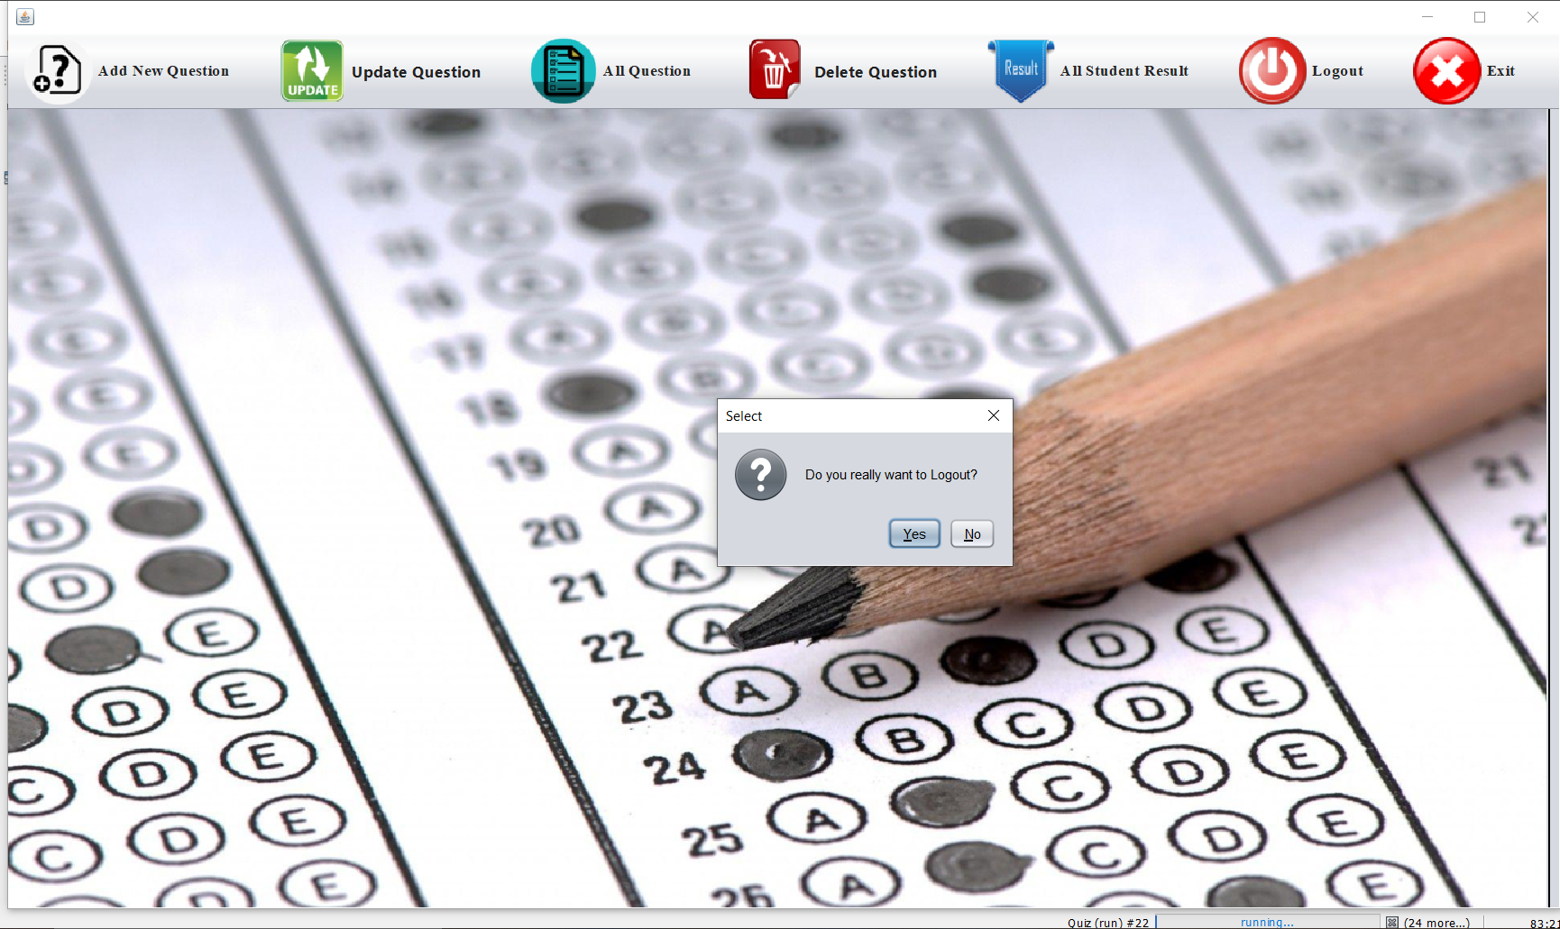

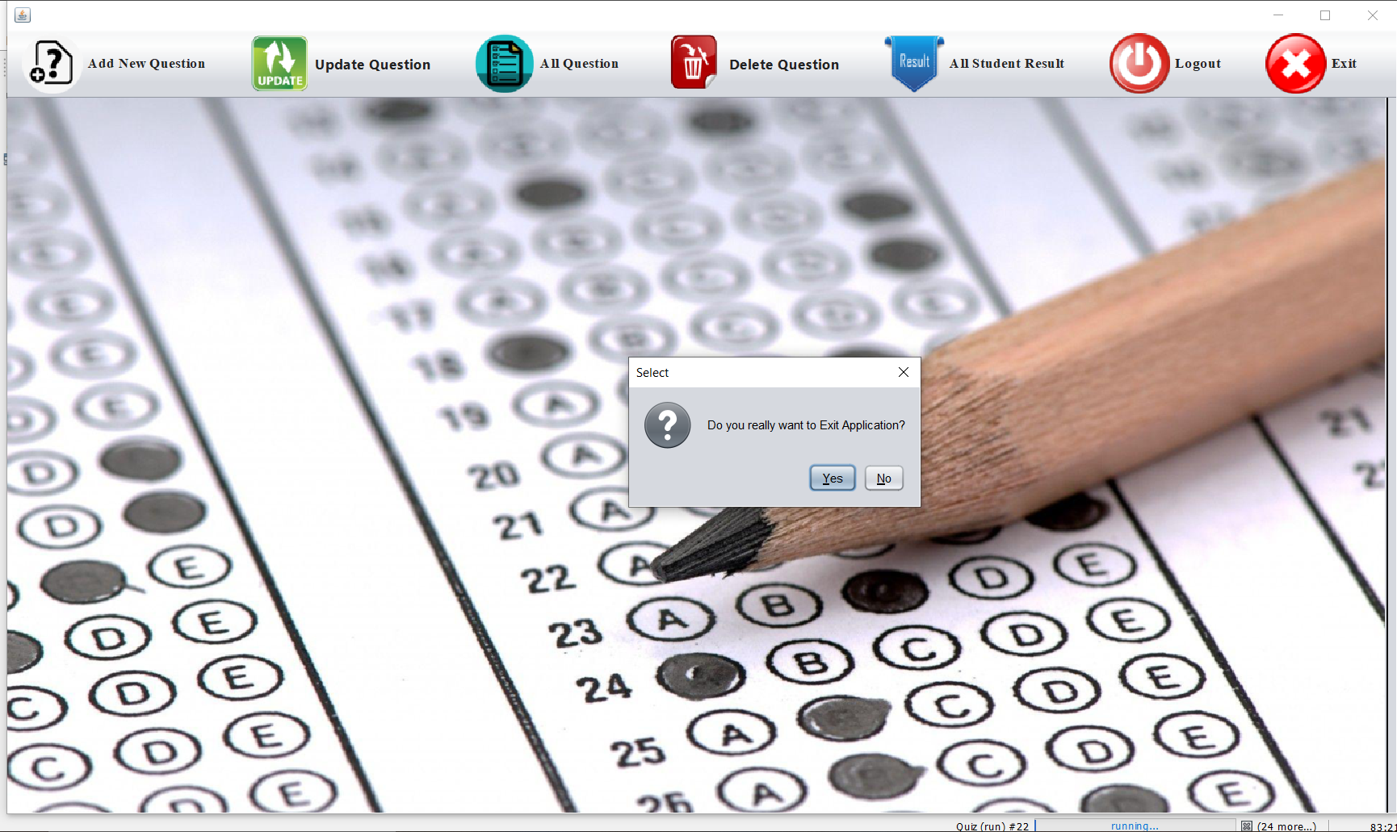

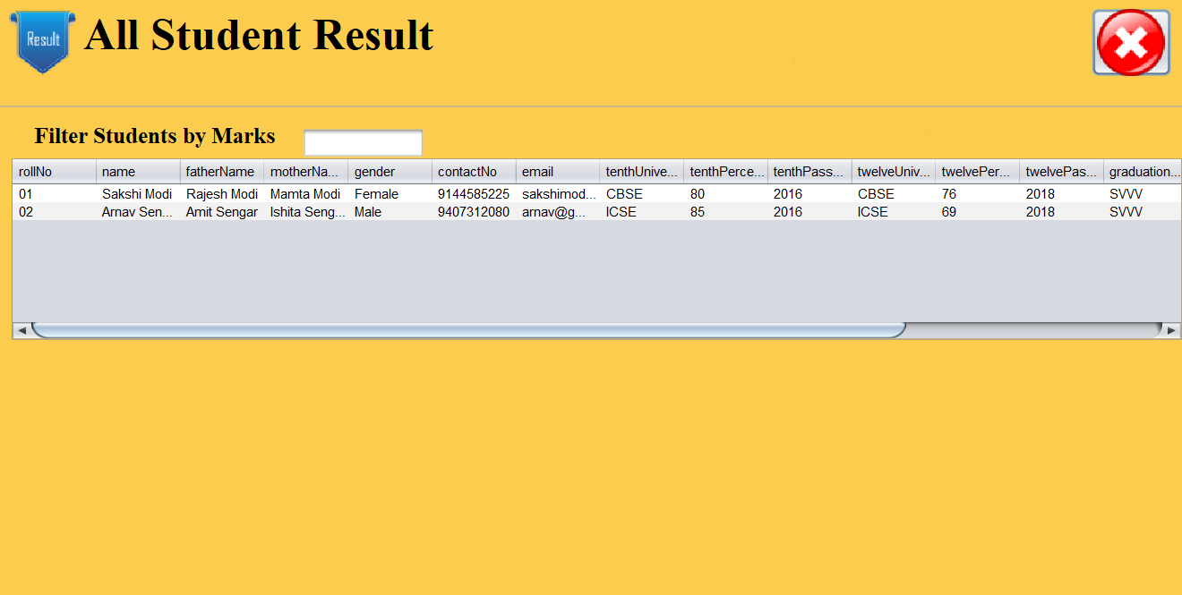

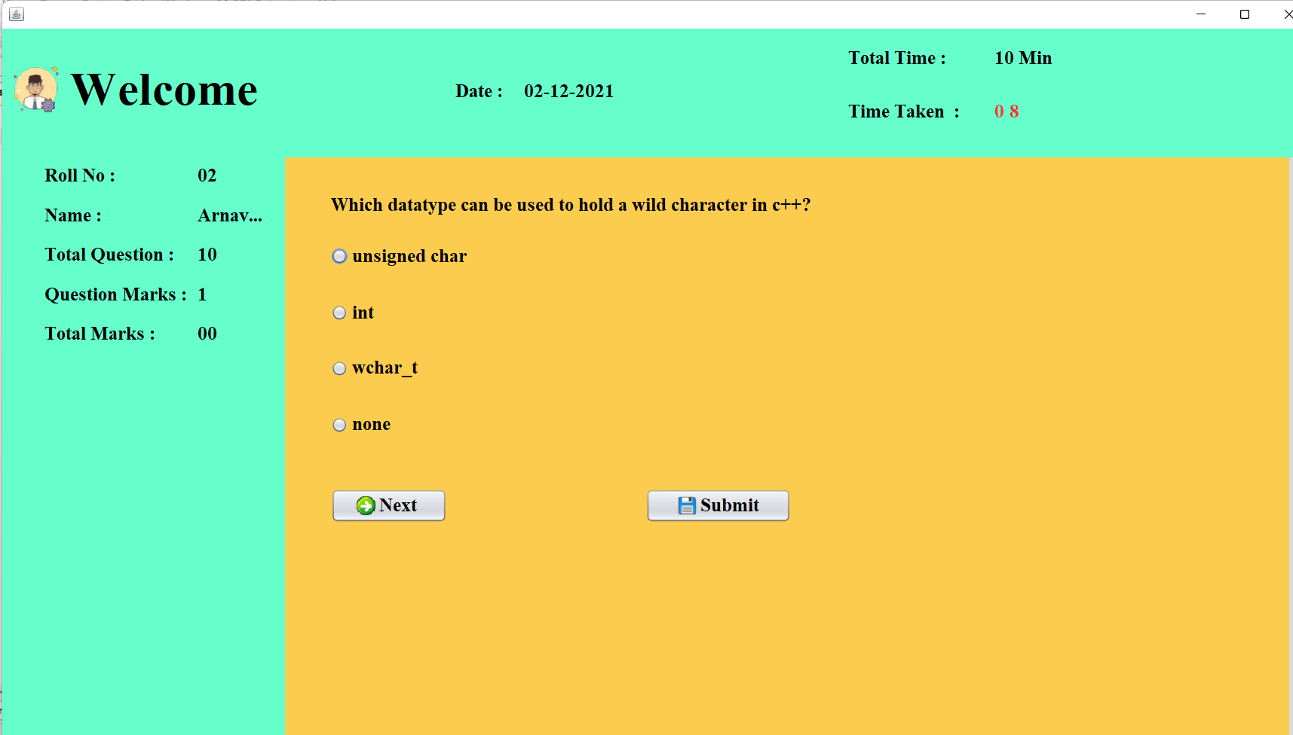

**CHAPTER 6-CONCLUSION AND FRAMEWORK**

1. **Limitation of Project**

Difficulty in grading long answer type question as this only provides MCQ feature.

Also limited to only few categories until now.

1. **Future Enhancement**

`Following are the features which we will implement for the future scope :

1. Camera proctored assessment.
2. One to one availability of mentor.
3. Full screen mode to unable tab switching.
4. Monthly subscription plans to use more features.

**CHAPTER 7-BIBLIOGRAPHY AND REFERENCES**

* 1. **Reference Books**
* Shubham Bobde, Suraj Chaudhari, Suraj Chaudhari and Jagupati Golguri,”Web Based Online Examination System” ,Volume 2, April 2017.
* Deepankar Vishwas Kotwal, Shubham ,Rajendra Bhadke ,Aishwarya Sanjay Gunjal and Puspendu Biswas,”online examination system”, Volume: 0, Jan-2016.
  + 1. **Other Documentation and References**
* [www.w3schools.com](http://www.w3schools.com)
* [www.stackoverflow.com](http://www.stackoverflow.com)
* <https://www.javatpoint.com/>
* <https://www.tutorialspoint.com/index.htm>